Adjective Modifier

🔹 What Is Adjective Modifier?
# Source: AI Source: Provided by: [Data Path: Persons Table -> ID Column: 1, Name_En Column: Motasem Essam] -> From: [Chatgpt (GPT‑5 Mini)] on [8/7/2025]
An adjective modifier is a word, phrase, or clause that modifies a noun or pronoun by describing, limiting, or qualifying it. It answers questions like:
- What kind?
- Which one?
- How many?
- Whose?

🔸 Forms of Adjective Modifiers:
# Source: AI Source: Provided by: [Data Path: Persons Table -> ID Column: 1, Name_En Column: Motasem Essam] -> From: [Chatgpt (GPT‑5 Mini)] on [8/7/2025]
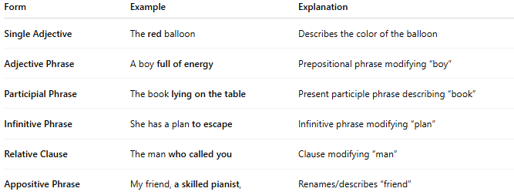
Form | Example | Explanation
Single Adjective | The red balloon | Describes the color of the balloon
Adjective Phrase | A boy full of energy | Prepositional phrase modifying “boy”
Participial Phrase | The book lying on the table | Present participle phrase describing “book”
Infinitive Phrase | She has a plan to escape | Infinitive phrase modifying “plan”
Relative Clause | The man who called you | Clause modifying “man”
Appositive Phrase | My friend, a skilled pianist, | Renames/describes “friend”

🔹 Placement:
# Source: AI Source: Provided by: [Data Path: Persons Table -> ID Column: 1, Name_En Column: Motasem Essam] -> From: [Chatgpt (GPT‑5 Mini)] on [8/7/2025]
Adjective modifiers typically appear directly before or after the noun/pronoun they modify.
- Before the noun:
→ She wore a beautiful dress.
- After the noun (with phrases or clauses):
→ The student with the best grades won a prize.
→ The woman who teaches us is kind.

✅ Summary:
# Source: AI Source: Provided by: [Data Path: Persons Table -> ID Column: 1, Name_En Column: Motasem Essam] -> From: [Chatgpt (GPT‑5 Mini)] on [8/7/2025]
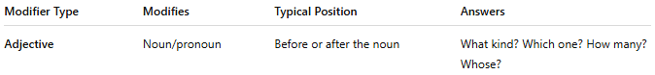
Modifier Type | Modifies | Typical Position | Answers
Adjective | Noun/pronoun | Before or after the noun | What kind? Which one? How many? Whose?

